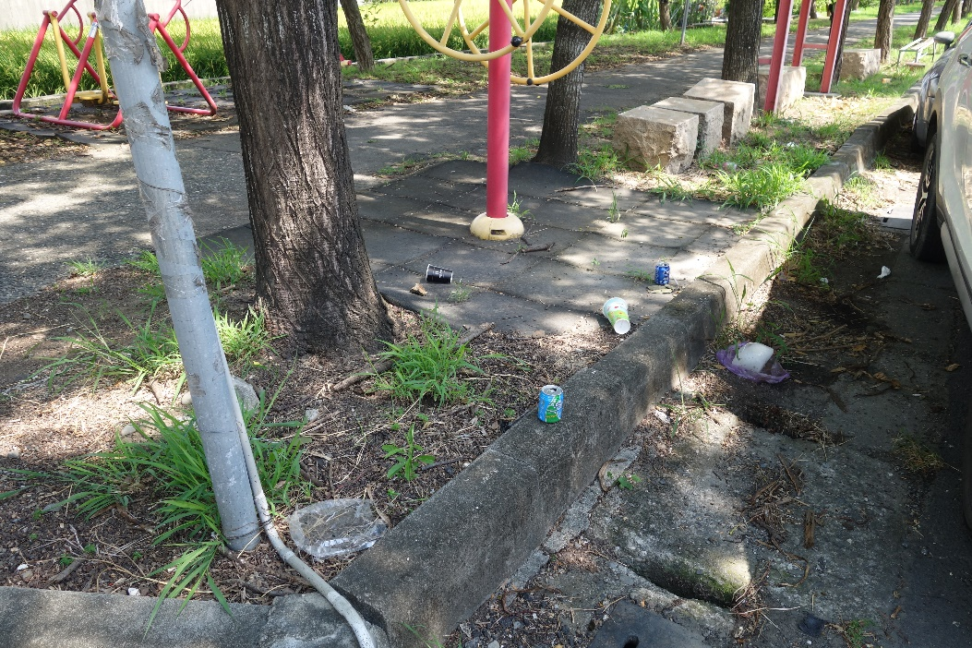
Community Service
Actual state of the environment of Xingnan Village before cleaning (1)
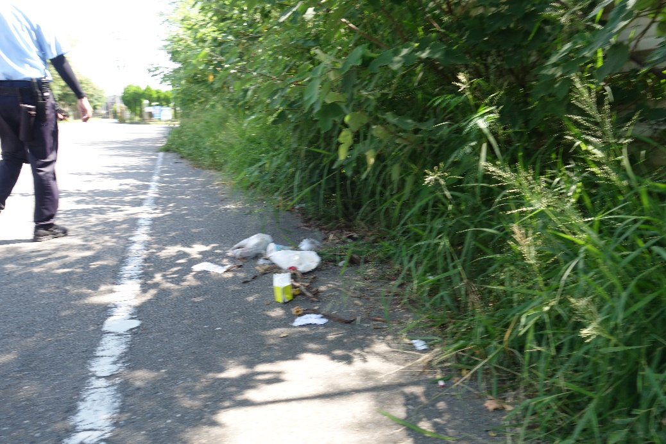
Actual state of the environment of Xingnan Village before cleaning (2)
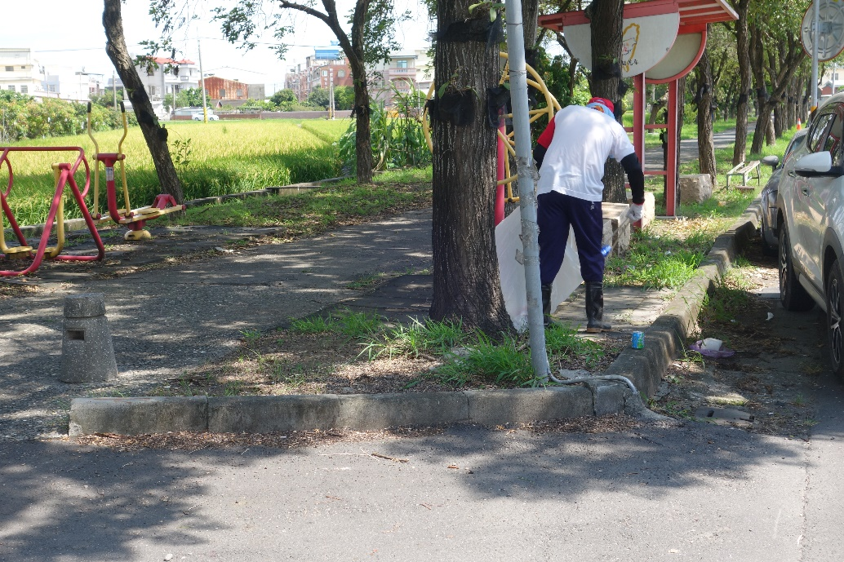
Actual cleaning execution (1)
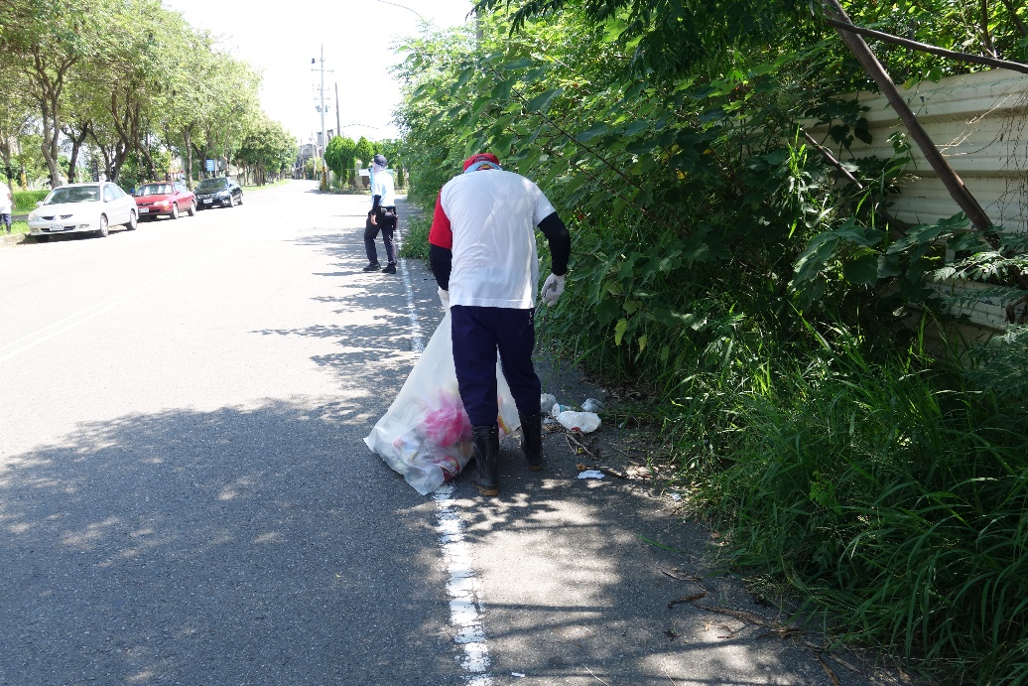
Actual cleaning execution (2)
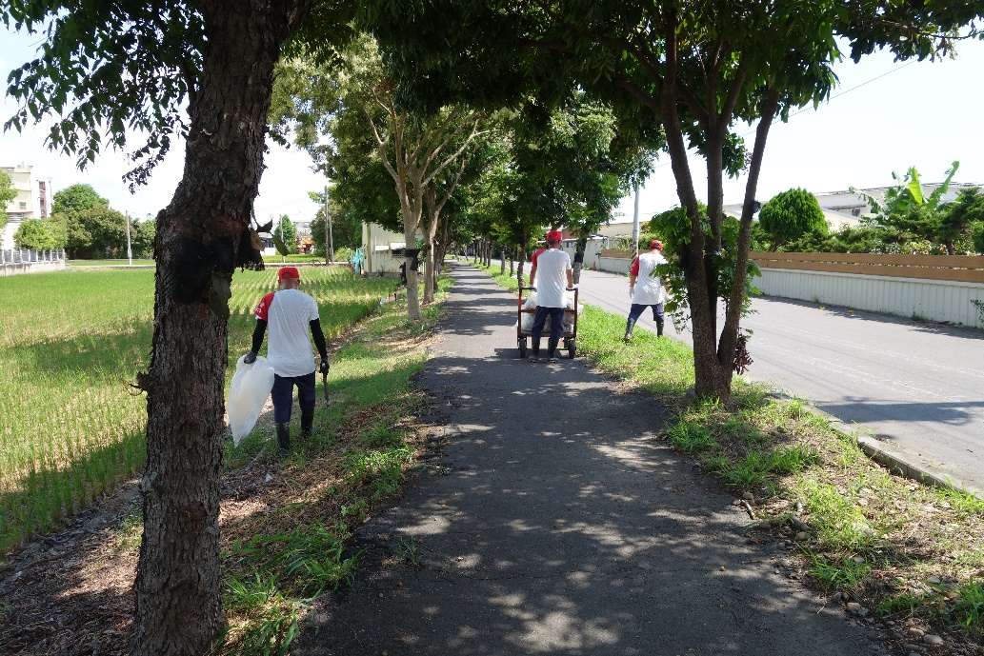
Actual cleaning execution (3)
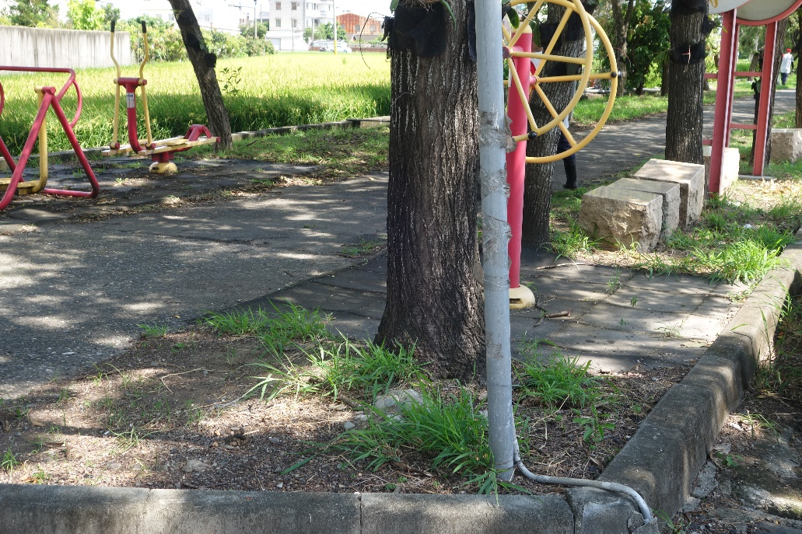
Actual state of the environment of Xingnan Village after cleaning (1)
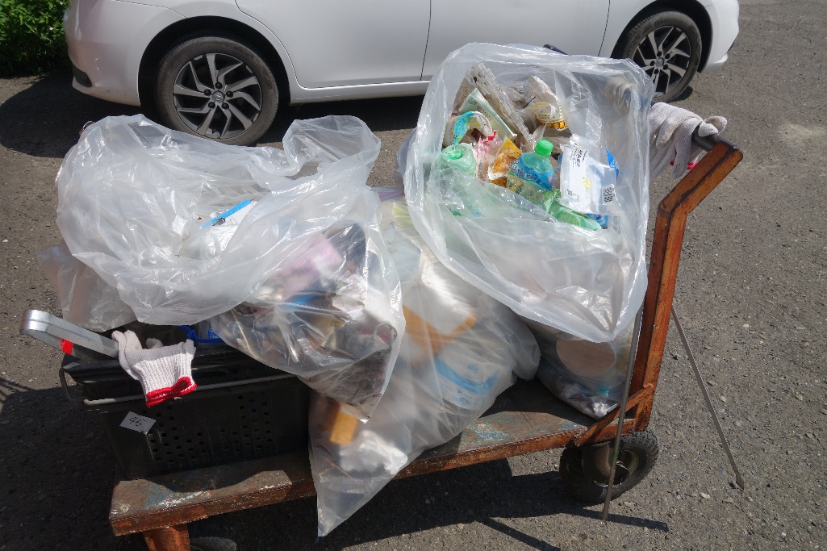
Actual state of the environment of Xingnan Village after cleaning (2)
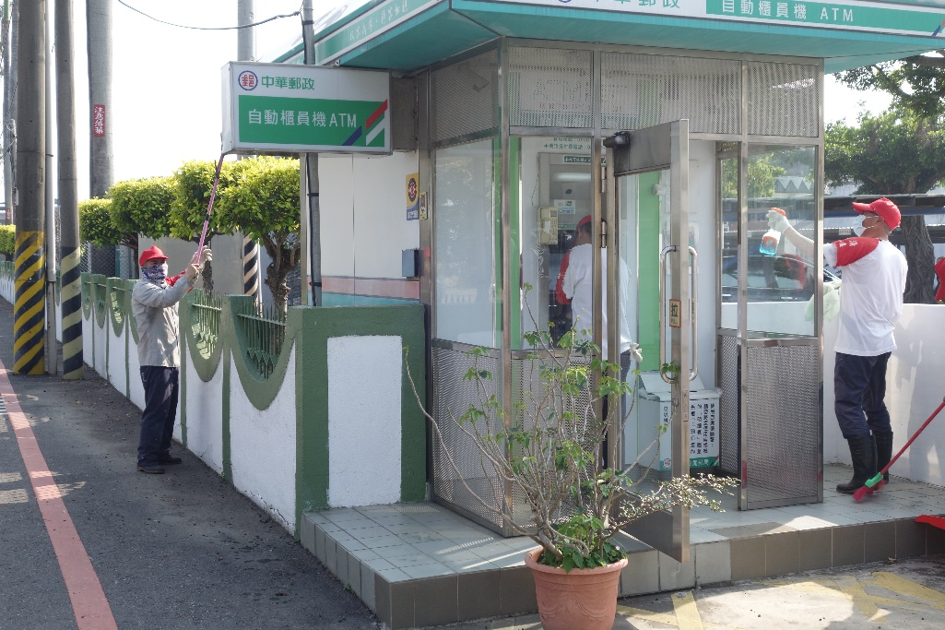
Actual state of the ATM cleaning

